Downloader for Kraken tick data



Author
Stefan Mallia
Table of Contents
1 Data Description 5
2 Storing the data: Database design 8
3 Structure of the program 9
4 References 10

List of Figures
Figure 1: The Orderbook as viewable on the Kraken website 5
Figure 2: Deletion of an orderbook level resulting in a republish 6

List of Table
Table 1: Trade JSON specification 6
Table 3: Orderbook snapshot JSON specification 6
Table 3: Depth Update JSON specification 7
Table 4: Order Book Database table definition 8
Table 5: Depth update Database table definition 8
Table 6: Trade Database table definition 8

Data Description
The orderlook is a ledger of orders on offer for the exchange of two assets. For example the EURUSD orderbook can be observed as in Figure 1.
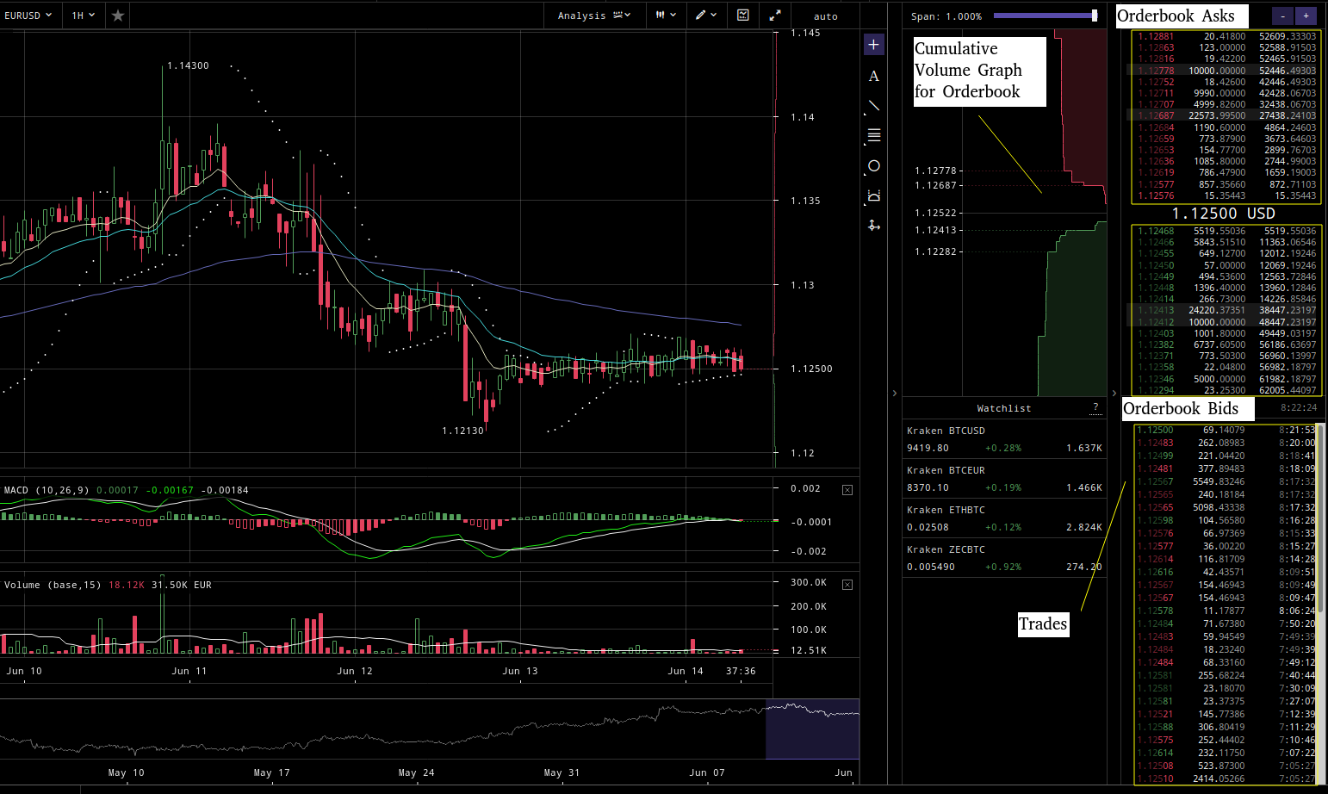Figure 1: The Orderbook as viewable on the Kraken website

The two main data streams provided by Kraken’s websocket API consist of information of updates of orders on the orderbook and of executed trades. The Kraken websocket API also provides realtime spread data, periodic ohlc (open, high, low, close), and other general ticker data. However, this is all contained in the first two data streams and are thus are not downloaded within this application.
The depth update stream sends a single snapshot of the orderbook on subscription, after which individual order data for updating, deleting, or inserting an orderbook level are sent. An orderbook level is represented by the price level of the order.
Kraken manages its orderbook stream up to a specified number of order levels, for example 10, 25, 100, 1000. Order changes above these levels are ignored, however, if there is a delete below the highest level, a ‘republish’ level is sent to represent an order reentering the update-able range as shown in Figure 2, which assumes that depth, the number of levels for which updates are received, is 5.
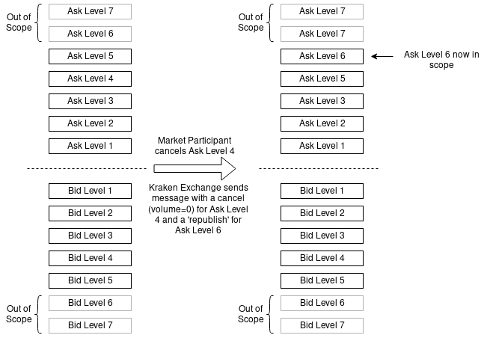Figure 2: Deletion of an orderbook level resulting in a republish

The data is represented in JSON format as follows.
Table 1: Trade JSON specification
Name | Type | Description
channelID | integer | ChannelID of pair-trade subscription
Array | array
– Array | array
– – price | float | Price
– – volume | float | Volume
– – time | float | Time, seconds since epoch
– – side | string | Triggering order side, buy/sell
– – orderType | string | Triggering order type market/limit
– – misc | string | Miscellaneous
channelName | string | Channel Name of subscription
pair | string | Asset pair

Table 3: Orderbook snapshot JSON specification
Name | Type | Description
channelID | integer | ChannelID of pair-order book levels subscription
(Anonymous) | object
– as | array | Array of price levels, ascending from best ask
– – Array | array | Anonymous array of level values
– – price | float | Price level
– – volume | float | Price level volume, for updates volume = 0 for level removal/deletion
– – timestamp | float | Price level last updated, seconds since epoch
– bs | array | Array of price levels, descending from best bid
– – Array | array | Anonymous array of level values
– – price | float | Price level
– – volume | float | Price level volume, for updates volume = 0 for level removal/deletion
– – timestamp | float | Price level last updated, seconds since epoch
channelName | string | Channel Name of subscription
pair | string | Asset pair

Table 3: Depth Update JSON specification
Name | Type | Description
channelID | integer | ChannelID of pair-order book levels subscription
AnyOf | anyOf
– (Anonymous) | object | Container for ask updates
– – a | array | Ask array of level updates
– – – (Array) | array | Anonymous array of level values
– – – – price | float | Price level
– – – – volume | float | Price level volume, for updates volume = 0 for level removal/deletion
– – – – timestamp | float | Price level last updated, seconds since epoch
– – – – updateType | string | Optional - "r" in case update is a republished update
– (Anonymous) | object | Container for bid updates
– – b | array | Bid array of level updates
– – – (Array) | array | Anonymous array of level values
– – – – price | float | Price level
– – – – volume | float | Price level volume, for updates volume = 0 for level removal/deletion
– – – – timestamp | float | Price level last updated, seconds since epoch
– – – – updateType | string | Optional - "r" in case update is a republished update
channelName | string | Channel Name of subscription
pair | string | Asset pair

Storing the data: Database design
Since there are three streams (orderbook snapshots, orderbook updates, and trades), three different types of tables are defined. These tables are created for each asset pair.
Table 4: Order Book Database table definition
row_id (P) | SMALLSERIAL
price | DECIMAL
volume | DECIMAL
timestamp | TIMESTAMP WITH TIME ZONE
local_time (P) | TIMESTAMP WITH TIME ZONE
index_in_message | SMALLINT
is_ask | BOOL

Table 5: Depth update Database table definition
row_id (P) | SMALLSERIAL
price | DECIMAL
volume | DECIMAL
is_republish | BOOL
timestamp | TIMESTAMP WITH TIME ZONE
local_time (P) | TIMESTAMP WITH TIME ZONE
index_in_message | SMALLINT
is_ask | BOOL

Table 6: Trade Database table definition
row_id (P) | SMALLSERIAL
price | DECIMAL
volume | DECIMAL
timestamp | TIMESTAMP WITH TIME ZONE
local_time (P) | TIMESTAMP WITH TIME ZONE
side | BOOL
order_type | BOOL
misc | VARCHAR
index_in_message | SMALLINT

In each table, row_id and local_time are defined as primary keys. row_id is a serial, meaning that it is incremented automatically by the database on each insert. Since it is being used in conjunction with local_time, it is defined as a small datatype for storage efficiency. Uniqueness is virtually guaranteed as no table will see more than 32,767 inserts within a microsecond. Using local_time with row_id is necessary because local_time is not a unique value, a message from Kraken may contain multiple inserts of data, which will be given the same local_time value but have different row_id values.

Structure of the program

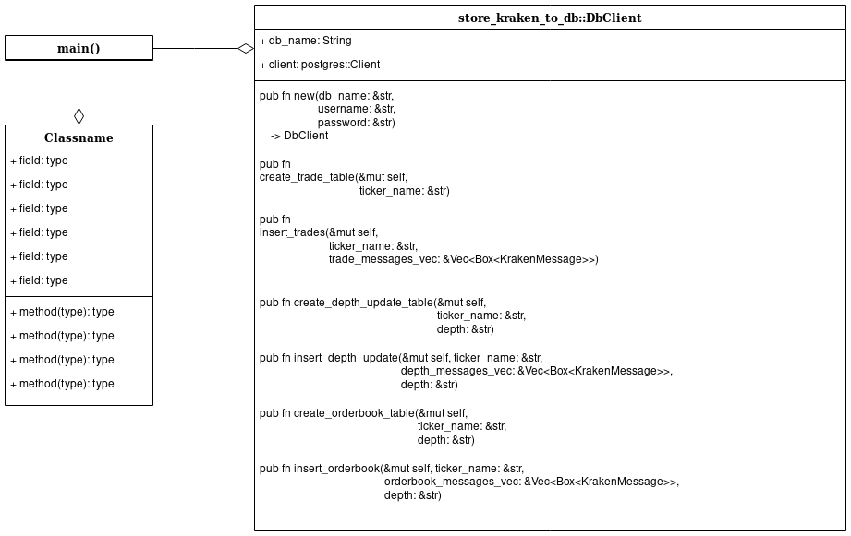

Implementation details of the Program

References
- https://docs.kraken.com/websockets/
- https://support.kraken.com/hc/en-us/sections/360003493672-WebSocket-API

